Date:

Lab # 02 TO UNDERSTAND THE CONCEPT OF UNIVERSAL NAND AND NOR GATES IN

Digital Circuit Design
Objectives:
O1: To understand the concept of universal NAND and NOR Gates O2: To implement Logic Circuits using only NAND or NOR gates.

Background Theory

Because the NAND function has functional completeness all logic systems can be converted into NAND gates. This is also true for NOR gates. In principle, any combinatorial logic function can be realized with enough NAND gates and/or NOR Gates.

NAND Gate Equivalent of Basic Logic Gate
A NOR gate is simply an inverted OR gate.

NOT Gate:
A NOT gate is made by joining the inputs of a NAND gate together. Since a NAND gate is equivalent to an AND gate followed by a NOT gate, joining the inputs of a NAND gate leaves only the NOT gate.
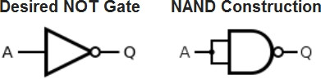

AND Gate:
An AND gate is made by following a NAND gate with a NOT gate as shown below.

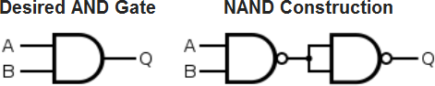

OR Gate:
If the truth table for a NAND gate is examined or by applying De Morgan's Laws, it can be seen that if any of the inputs are 0, then the output will be 1. To be an OR gate, however, the output must be 1 if any input is 1. Therefore, if the inputs are inverted, any high input will trigger a high output.

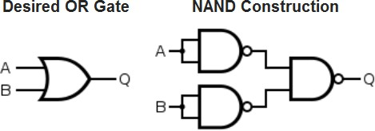

NOR Gate:
Output is high when neither input A nor input B is high:

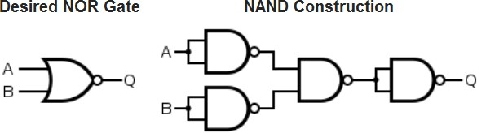

XOR Gate:
An XOR gate is constructed similarly to an OR gate, except with an additional NAND gate inserted such that if both inputs are high, the inputs to the final NAND gate will also be high, and the output will be low.
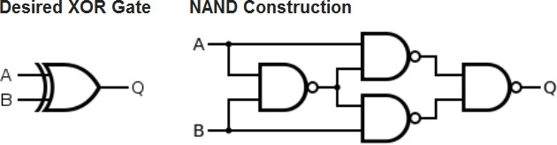

XNOR Gate:
An XNOR gate is simply an XOR gate with an inverted output:
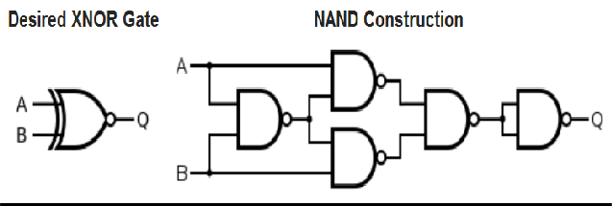

NOR Gate Equivalent of Basic Logic Gates
NOT Gate:

Same as that in NAND Logic, shorting the inputs of a NOR gate gets us a NOT gate:
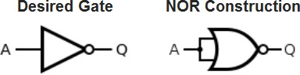

OR Gate:
The OR gate is simply a NOR gate followed by another NOR gate.

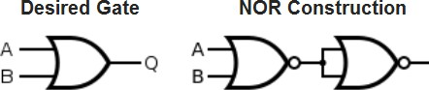

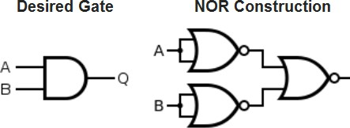
AND Gate:
A NAND gate is made using an AND gate in series with a NOT gate:

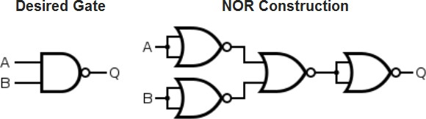
XOR Gate:
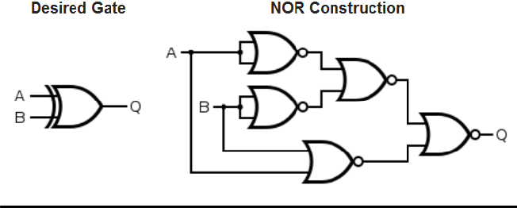
XNOR Gate:

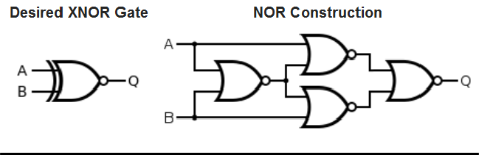

NAND Gate:
And Or Inverter (AOI) to NAND gate conversion steps
- If starting from a logic expression, implement the design with AOI logic.
- In the AOI implementation, identify and replace every AND, OR, and INVERTER gate with its NAND equivalent.
- Redraw the circuit.
- Identify and eliminate any double inversions (i.e., back-to-back inverters).
- Redraw the final circuit.
- Example conversion:
Boolean expression to be converted into Universal NAND equivalent:
𝒇(𝒄) = 𝑨 + 𝑩̅ + 𝑪
  - Implement the circuit using AOI Logic:
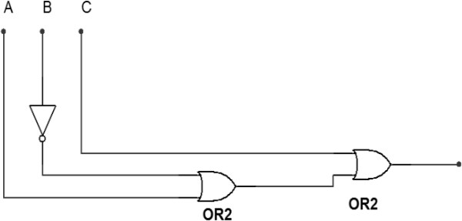
Fig 2.1: AOI Implementation of Boolean expression

  - Identify and replace every AND, OR and/or NOT gate with its NAND equivalent.
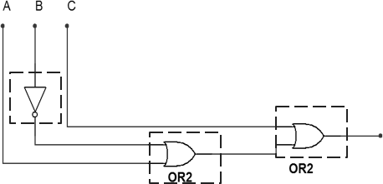
Fig 2.2: Identifying gates to be replaced

  - Redraw the circuit (using NAND counterparts).
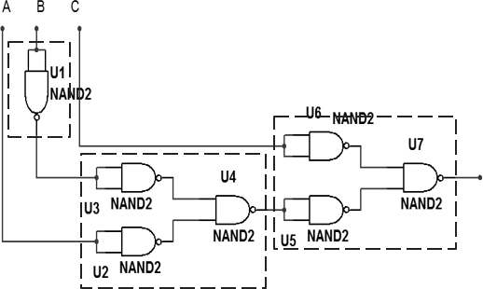
Fig 2.3: AOI replaced with NAND gates

  - Identify and eliminate any double inversions (i.e. back-to-back inverters).
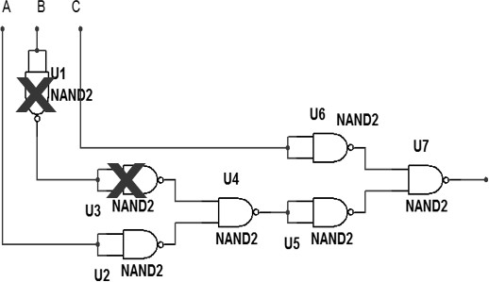
Fig 2.4: Eliminating double Inversions

  - Redraw the final circuit.

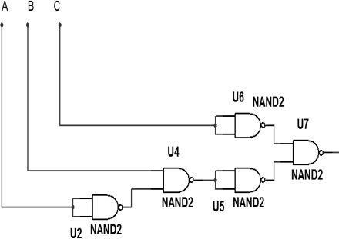
Fig 2.4: Final Circuit

  - The same procedure can be followed for conversion of AOI gates to Universal NOR Gates

Lab Task
Consider the Boolean expression given below:
𝑿 = 𝑨(𝑩 + 𝑪̅)
- Construct and AOI circuit for the expression and develop its Truth Table
- Convert the circuit into its Universal NAND equivalent
(Attach working on separate sheet).NAND Gate equivalent of the given expression:

Input A | Input B | Input C | Output Y

Input A | Input B | Input C | Output Y

Table 2.1: Truth table for the AOI circuit Table 2.2: Truth table for NAND
equivalent based Hardware circuit

HARDWARE REQUIRED:
  - Power supply with cables
  - Breadboard
  - Logic gate ICs: 1) NAND Gate
  - LEDs
  - Logic Probe (optional)

PROCEDURE:
- Construct the NAND equivalent circuit on bread board.
- Apply inputs and check corresponding Outputs.
- Note the readings in Table 2.2
- compare the two tables 2.1 and 2.2
- Was the conversion successful? If yes, Design the equivalent circuit for the following expression using Universal NOR Gate (attach working onseparate sheet):
𝑿 = 𝑨̅̅𝑩̅̅ + 𝑪̅̅𝑫̅̅
NOR Gate equivalent of the given expression:

Input A | Input B | Input C | Output Y

Input A | Input B | Input C | Output Y

Table 2.3: Truth table for the AOI circuit Table 2.4: Truth table for NOR
equivalent circuit.

CONCLUSION (What have you learnt from this experiment?):

LEARNING OUTCOMES
Upon successful completion of the lab, students will be able to:
LO1: Understand the importance of NAND and NOR Gates as Universal gates.
LO2: Apply the rules of converting AOI Gates to their Universal NAND or Universal NOR equivalents.

